How to Batch Import Cadets into Conover online with CSV File

- Create a Conover Online Account at
https://ajrotc.conovercompany.com/users/sign_in

- Once your instructor account is created, select Create Account in the top bar

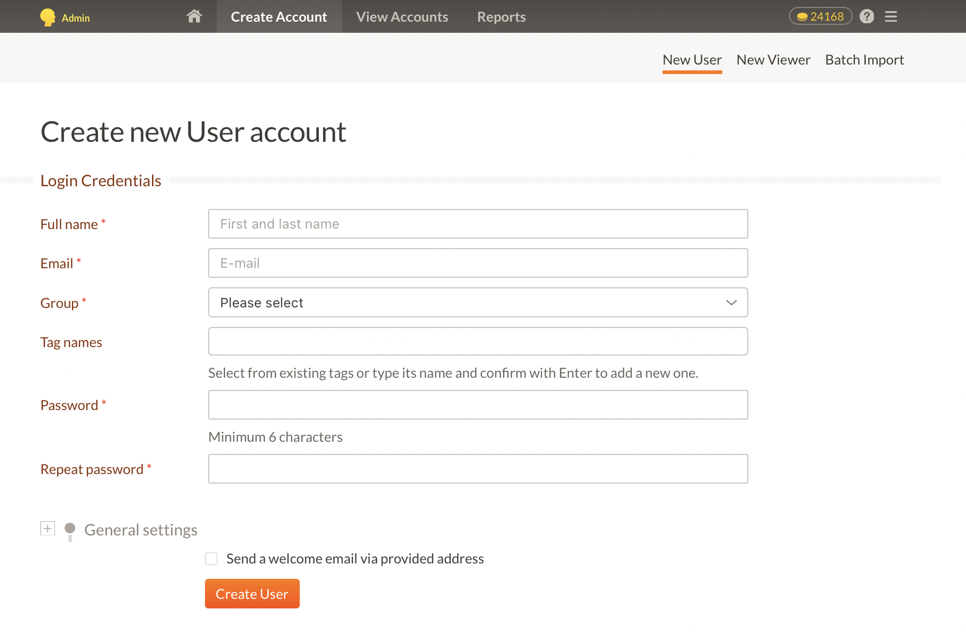

- Select Batch Import at the top right
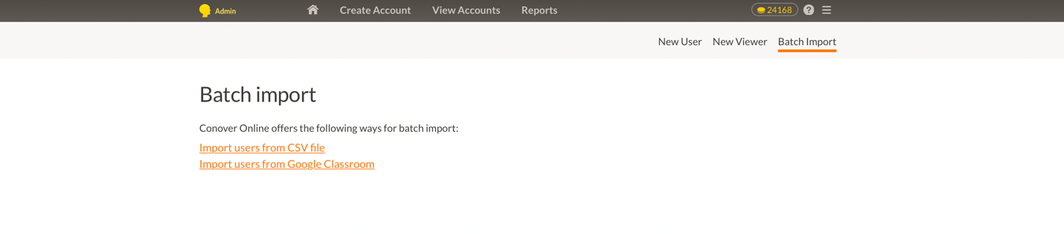
- Select Import User from CSV File
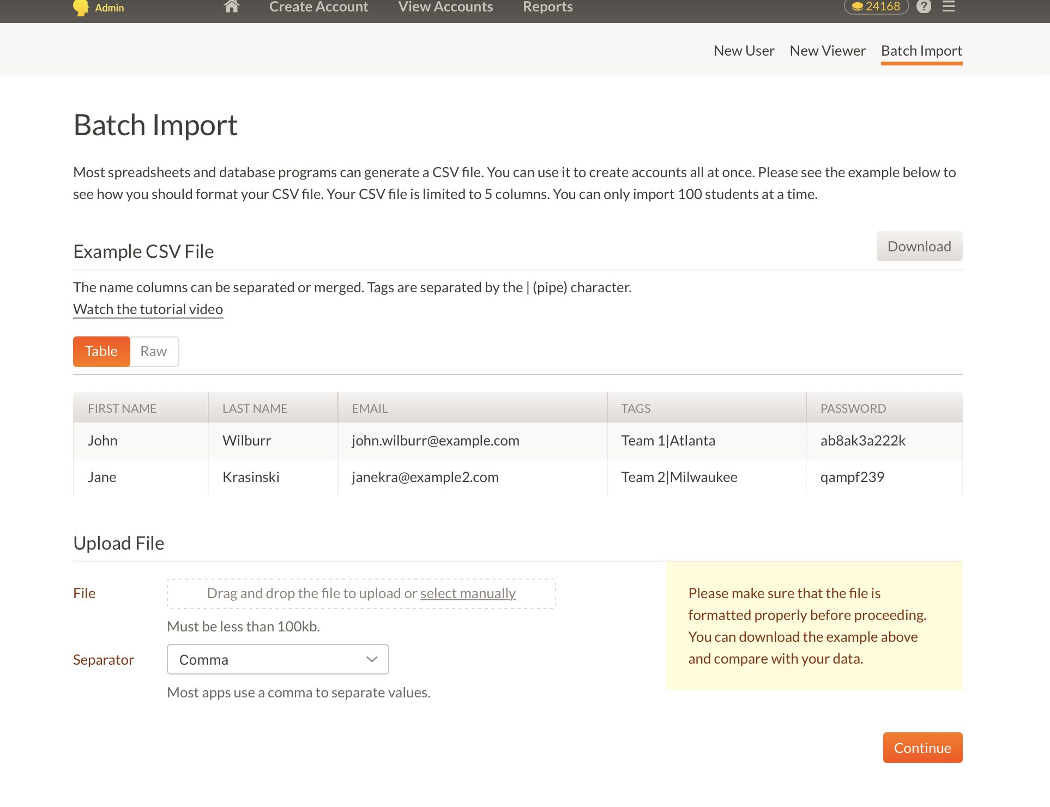

Here is a link to the Conover Tutorial on importing
https://conoveru.com/batch-import-user/

- The CSV template can be downloaded on this page

Be advise that the limit for each batch import is 100 cadets. If you have more than 100 cadets, create additional CSV files to import.

Here is what the template looks like.

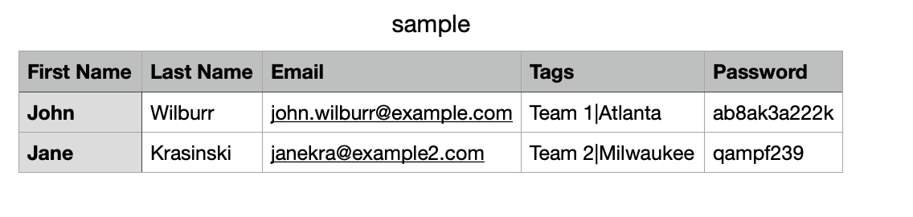
One technique is to create the account with their school email and provide them a standard password or if you prefer, create each cadet a unique password.
Provide the email and password to the cadet and they use that to log into Conover to take their PSM or additional supplemental material.
Tags can be unique or you can simply put your school name.

- Once the CSV file is imported on the previous screen shot, the continue button will take you to this screen
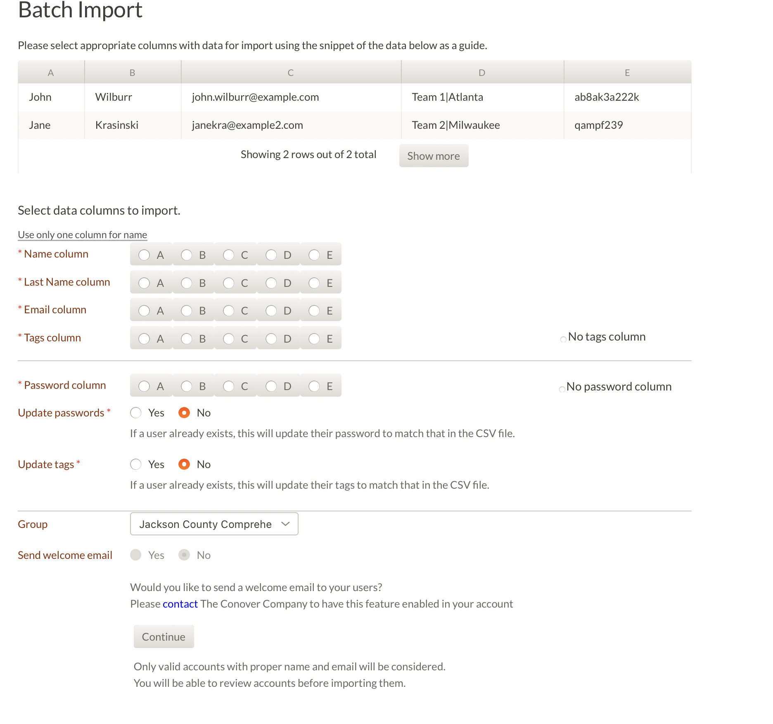
Complete the necessary selections and select Continue. You will get a preview screen
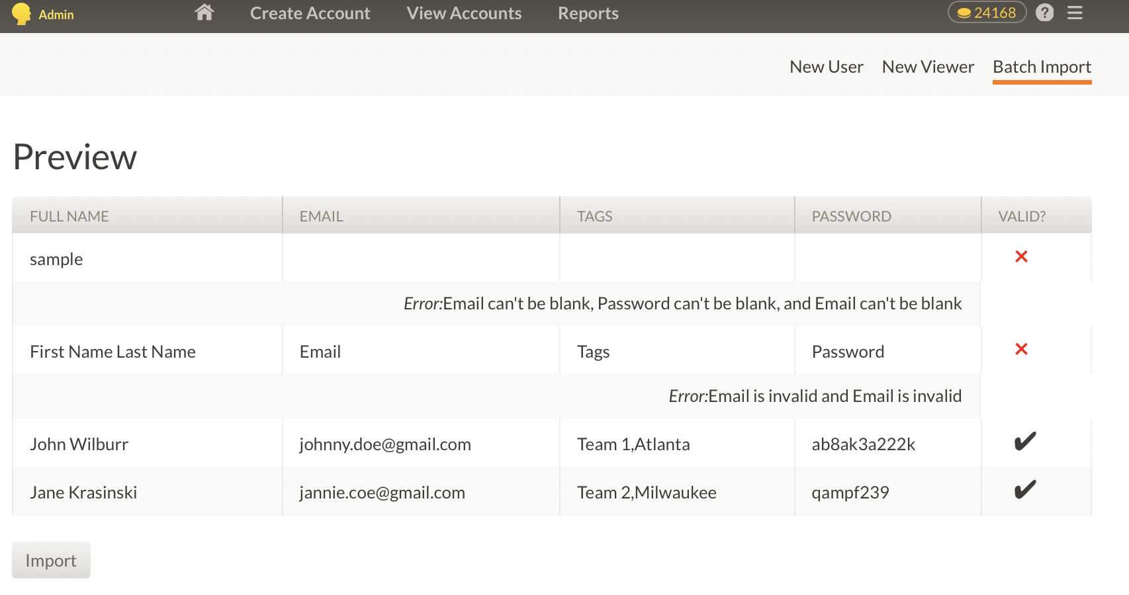
Note, if the valid column has a check mark, the account is good to go; and if you approve, select import

Once you import, you will receive notification that the import was successful

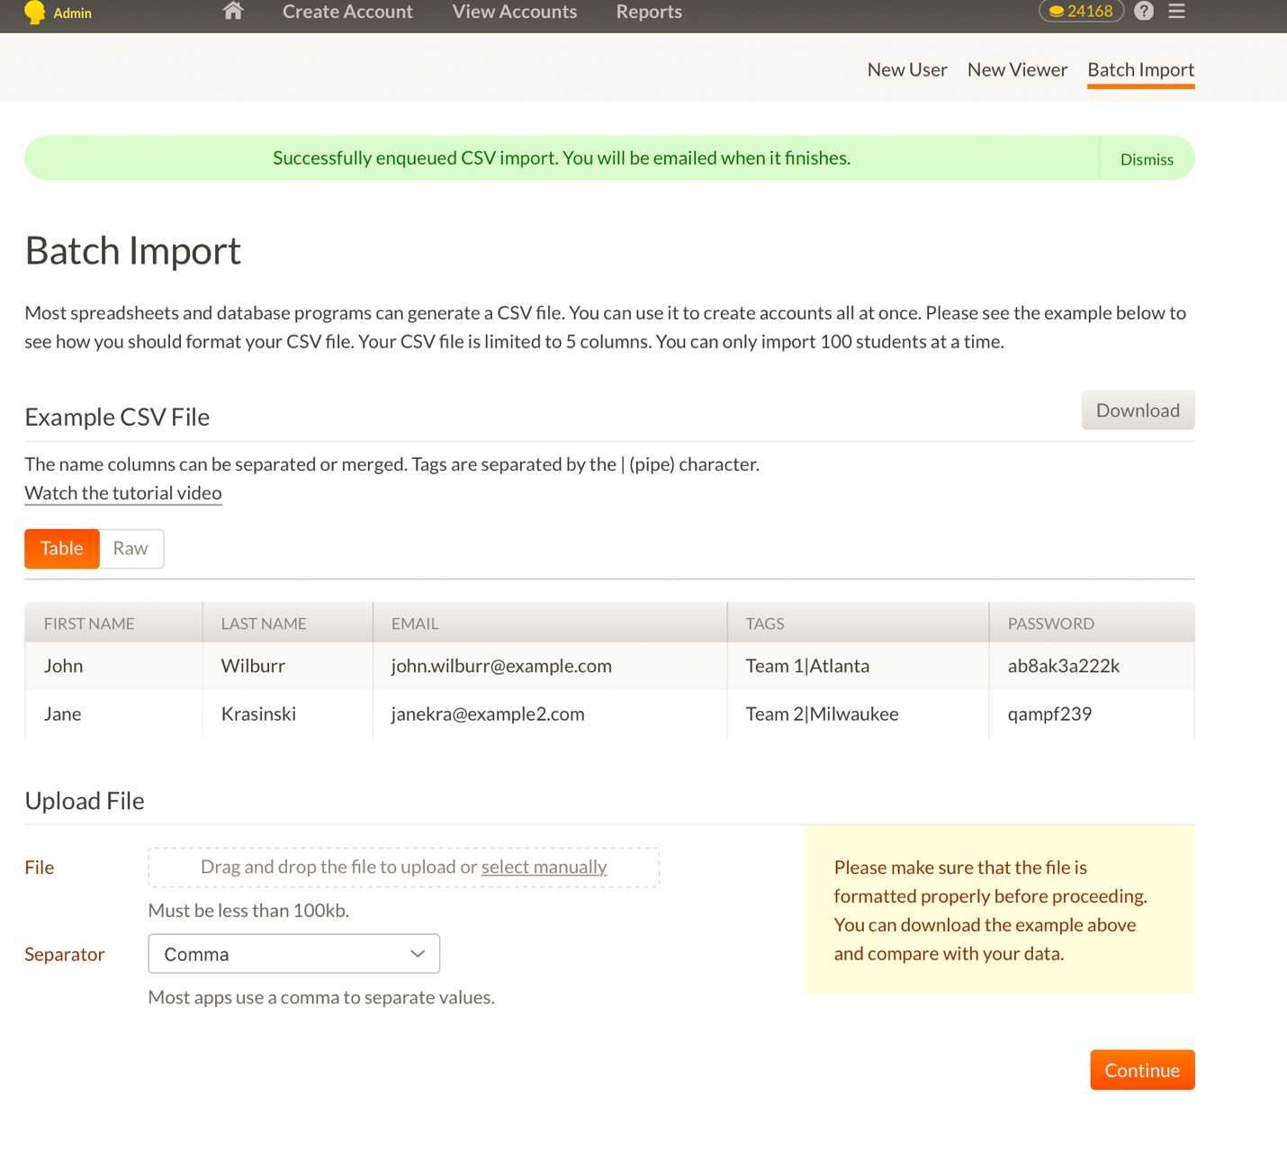

Now you will assign the PSM to your cadets and they can download the results as a PDF file and archive as appropriate.

